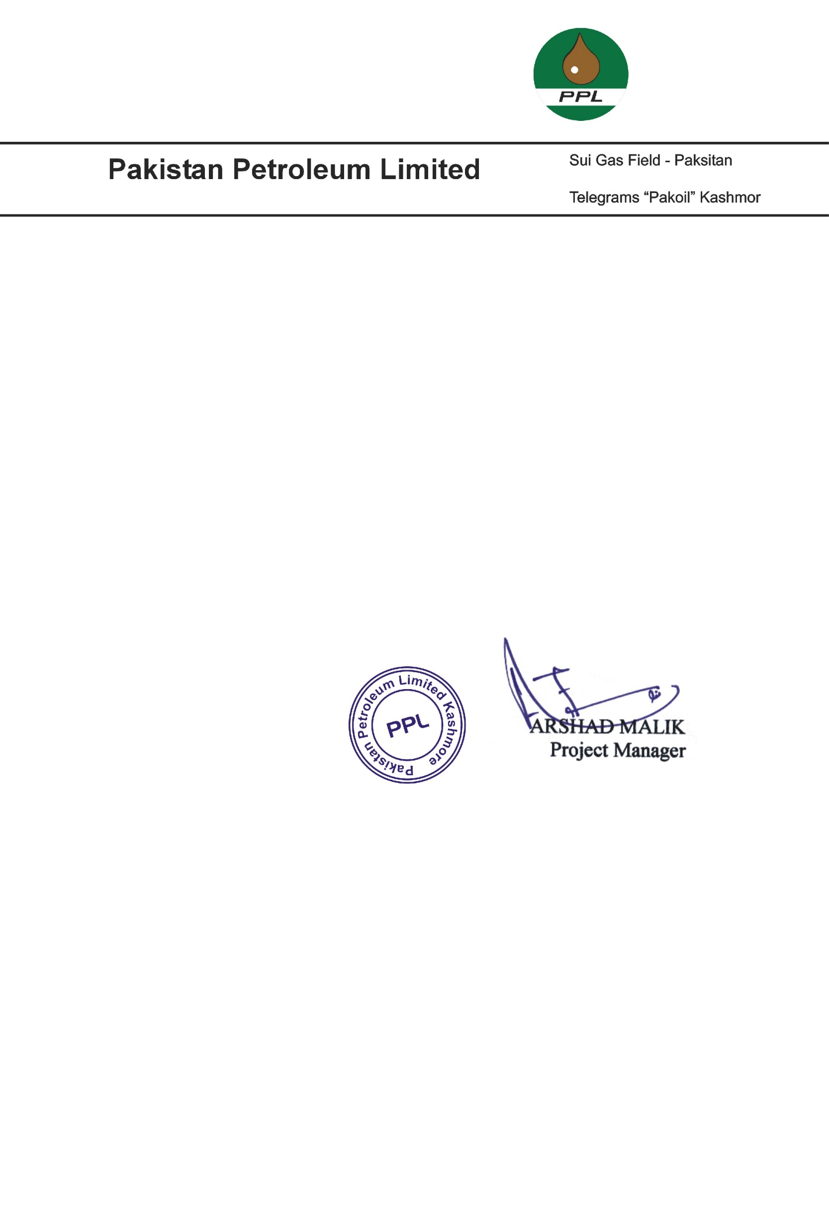

**TO WHOM IT MAY CONCERN**

This is certified that Mr. <Name> S/o Mr. <fname> has worked with us as a <Designation> in Sui Northern Gas Kashmore from <From2> to <To2>.

During this tenure we found him hard working and his services were satisfactory. We wish him best for his future.